COS 730
ASSIGNMENT 2
REPORT

Task 1: Baseline Implementation (Correctness Phase) 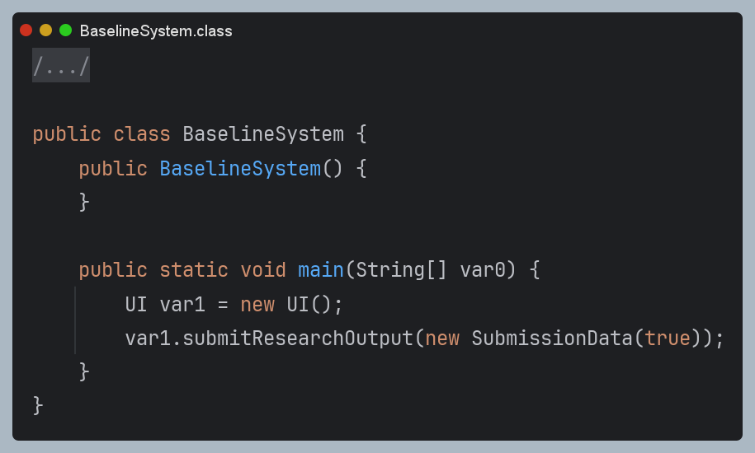
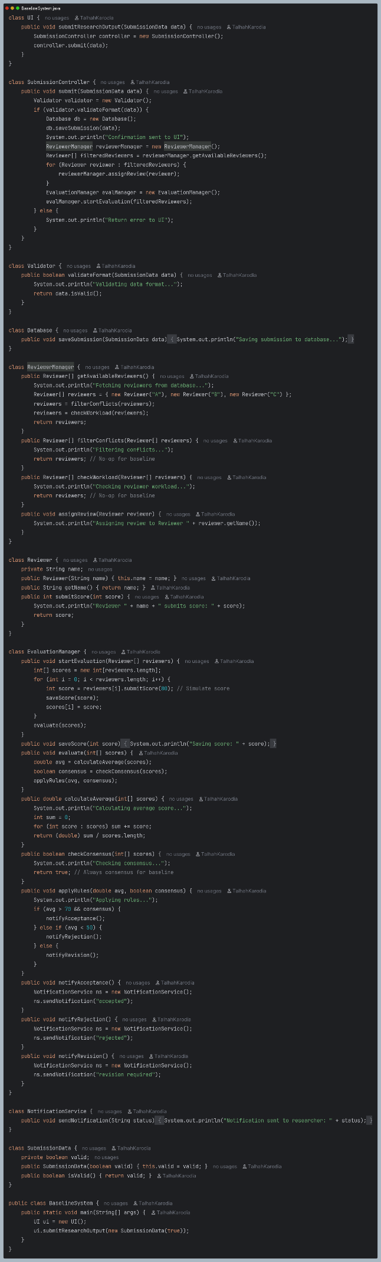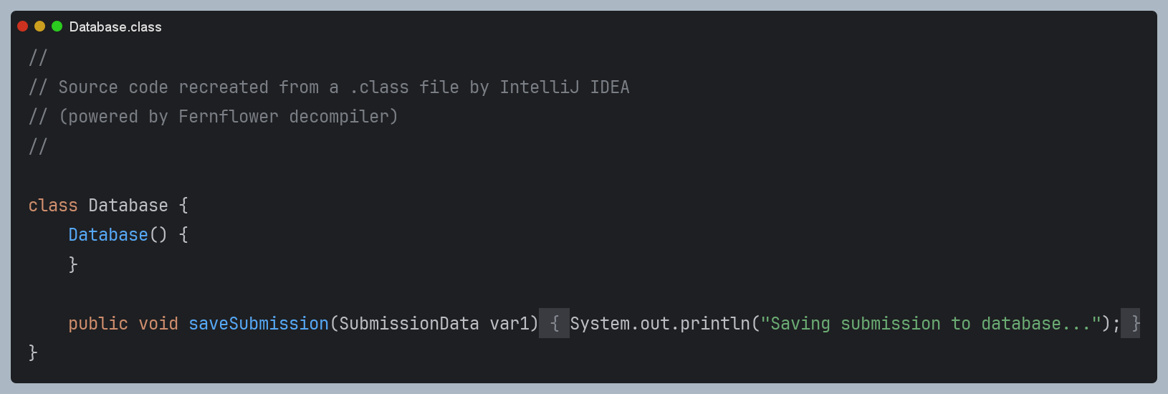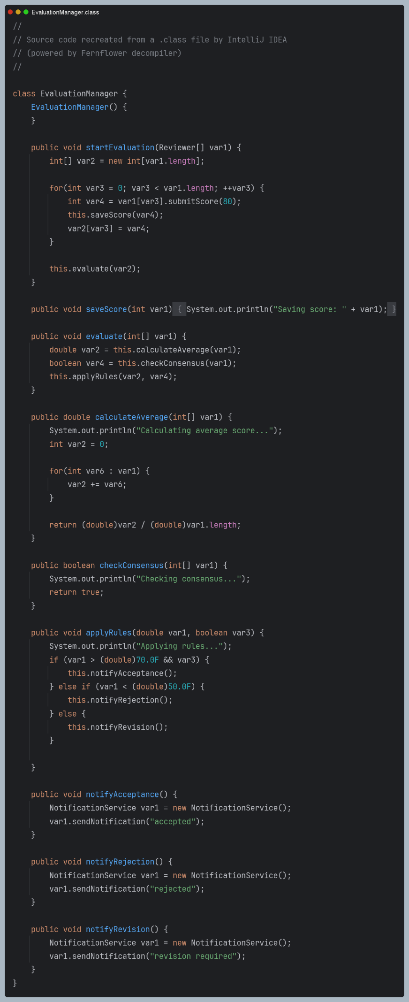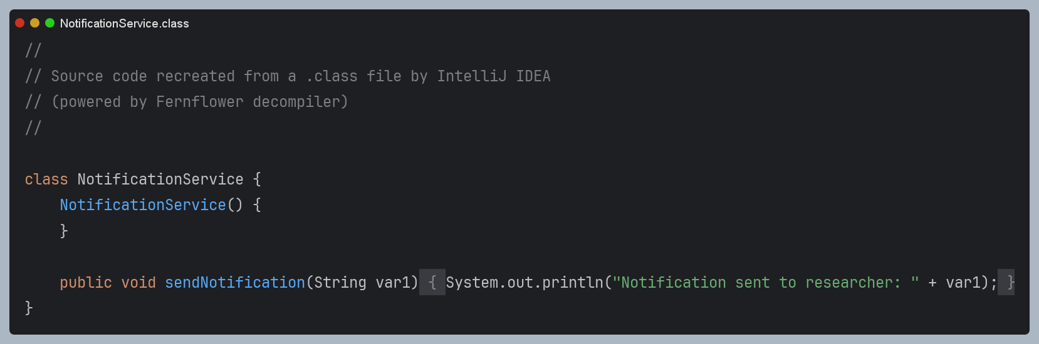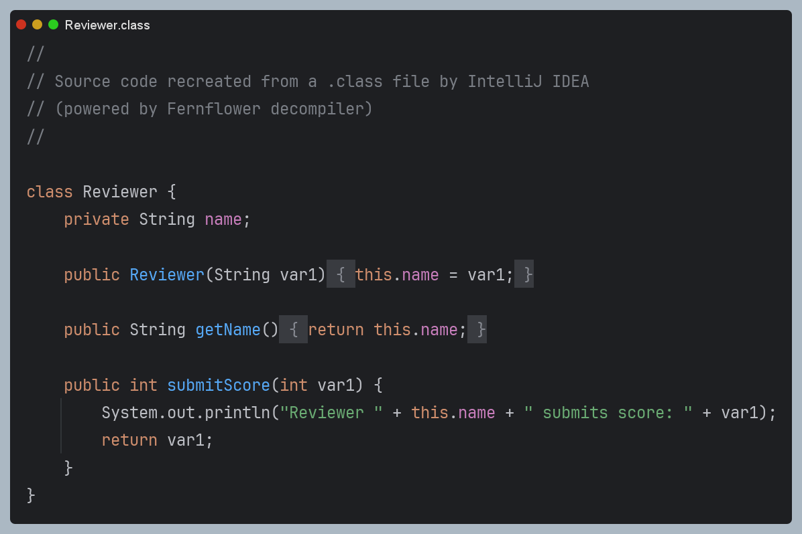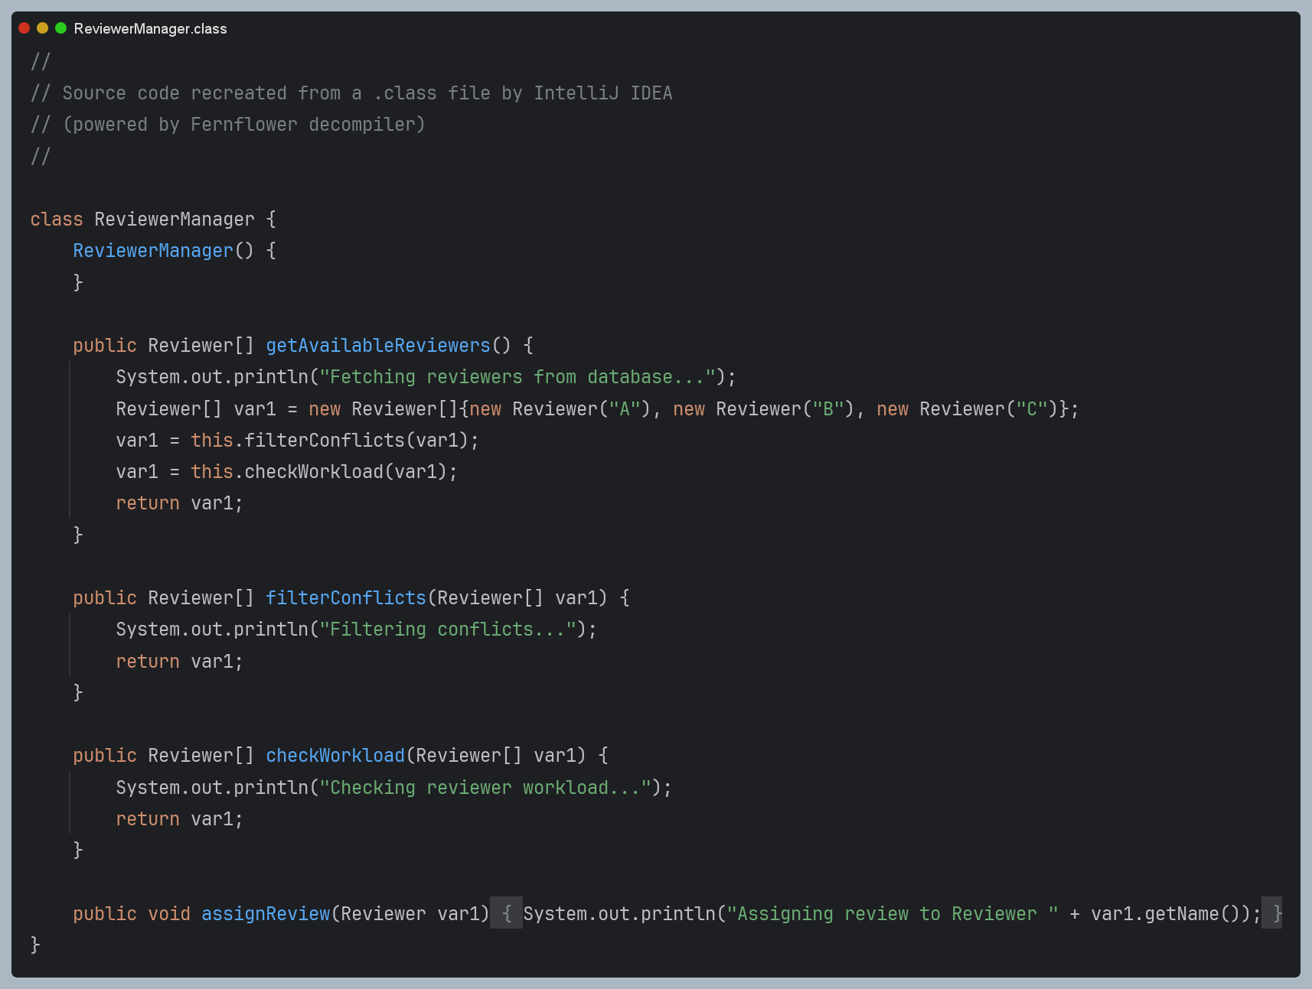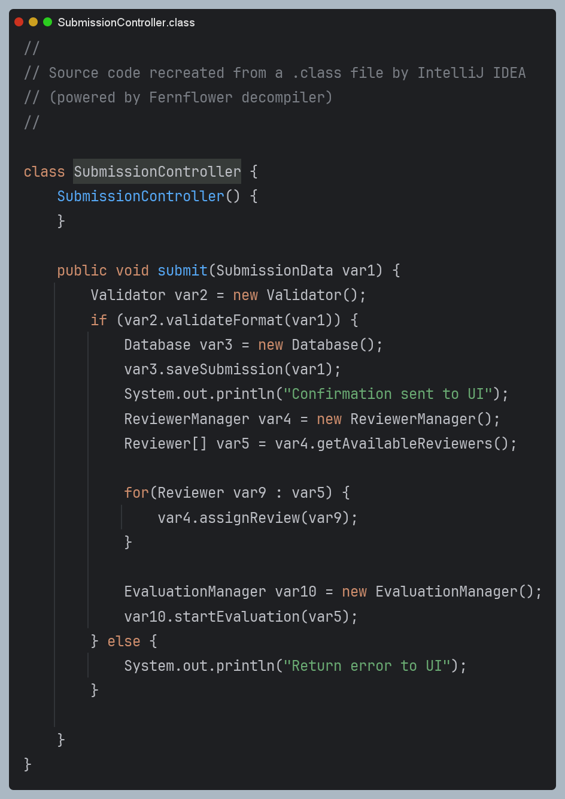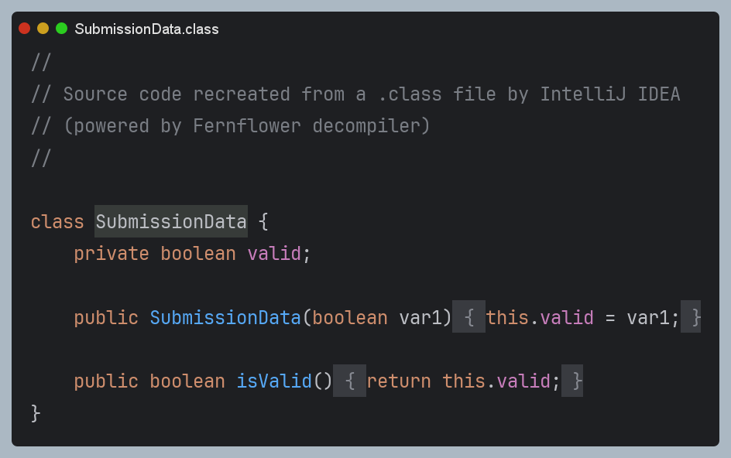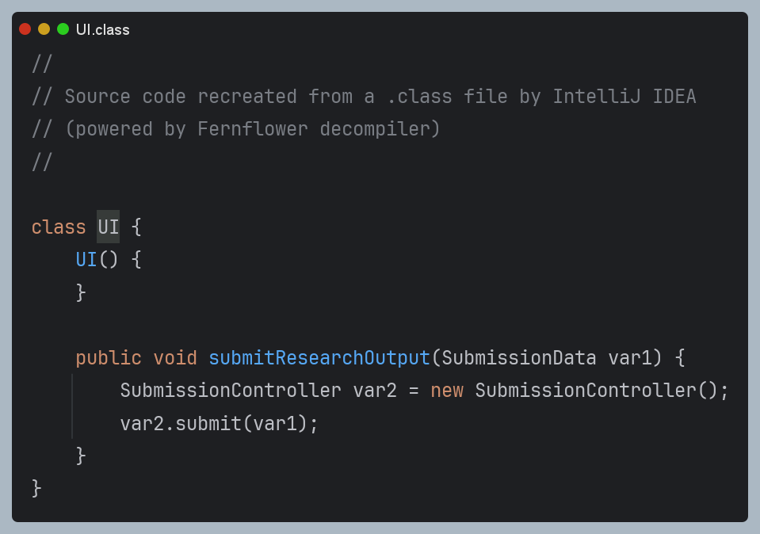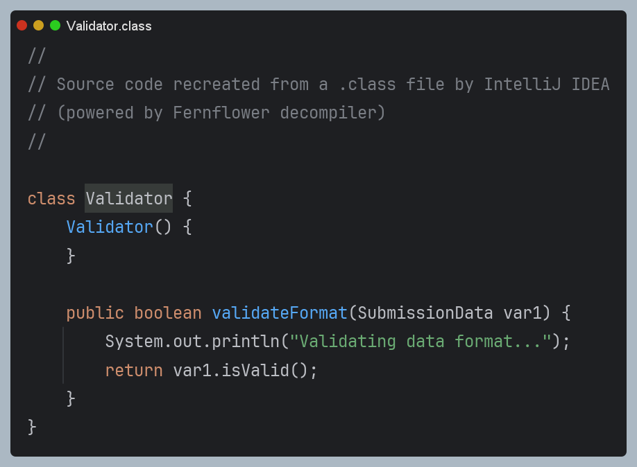

Task 2: Design Analysis – Baseline System
1. Redundant Message Calls
Multiple Filtering Steps:
ReviewerManager.getAvailableReviewers() calls both filterConflicts() and checkWorkload() in sequence, even if one could subsume the other or be combined.
Repeated Object Instantiations:
New instances of Validator, Database, ReviewerManager, and EvaluationManager are created for every submission, even if they could be reused or managed centrally.
2. Violations of Good Responsibility Assignment
SubmissionController Overload:
Handles validation, database interaction, reviewer assignment, and evaluation initiation, violating the Single Responsibility Principle (SRP).
ReviewerManager:
Both fetches reviewers and assigns them, mixing data access with business logic.
EvaluationManager:
Handles both score collection and decision logic, which could be separated for clarity.
3. High Coupling / Low Cohesion
Tight Coupling:
SubmissionController is tightly coupled to Validator, Database, ReviewerManager, and EvaluationManager.
Changes in one class (e.g., reviewer assignment logic) require changes in multiple places.
Low Cohesion:
Classes like SubmissionController and ReviewerManager have methods that are not closely related, reducing maintainability.
4. Inefficient Control Flow
Linear, Synchronous Flow:
All steps are performed in a strict sequence, with no opportunity for parallelism or asynchronous processing.
Loops in Controller:
The controller loops through reviewers to assign them, rather than delegating this responsibility.
5. Poor Handling of Decision Logic
Scattered Conditionals:
Decision logic for acceptance, rejection, or revision is embedded in EvaluationManager.applyRules(), making it hard to update or extend.
No Centralised Decision Table:
Rules are not explicit or easily modifiable.

Relation to Principles
Responsibility Assignment:
Violates SRP and Information Expert; responsibilities are not assigned to the most knowledgeable or appropriate class.
Behavioural Modelling Quality:
The model is functionally correct but not modular, maintainable, or extensible.

Task 3: Decision Modelling Using a Decision Table
Extracted Decision Logic
From the baseline system, the main decision logic is in:
Validation (valid/invalid submission)
Evaluation outcome (acceptance, rejection, revision)
Conditions / Actions | Rule 1 | Rule 2 | Rule 3 | Rule 4
C1: Valid Format | Y | Y | Y | N
C2: Avg Score > 70 | - | Y | N | -
C3: Consensus | - | Y | N | -
C4: Avg Score < 50 | - | N | Y | -
A1: Save Submission | Y | Y | Y | N
A2: Assign Reviewers | Y | Y | N | N
A3: Start Evaluation | Y | Y | N | N
A4: Notify Acceptance | N | Y | N | N
A5: Notify Rejection | N | N | Y | N
A6: Notify Revision | N | N | N | N
A7: Return Error | N | N | N | Y

Rules:
If C1 is N: A7 (Return Error)
If C1 is Y: A1, A2, A3
If C2 and C3 are Y: A4 (Notify Acceptance)
If C4 is Y: A5 (Notify Rejection)
Else: A6 (Notify Revision)
How the Decision Table Improves Clarity and Maintainability
Centralises all decision logic in one place, making it easy to update rules.
Eliminates ambiguity by making all conditions and actions explicit.
Improves maintainability: Changes to rules require only updating the table, not scattered code.
Maps directly to system behaviour: Each row/action corresponds to a method or message in the system.

Task 4: Sequence Diagram Optimisation
Optimisation Goals
Reduce unnecessary interactions (e.g., combine reviewer filtering).
Improve responsibility allocation (move logic to appropriate classes).
Decouple system components (use interfaces, reduce direct instantiation).
Centralise decision logic (use a DecisionEngine).
Optimised Sequence Diagram
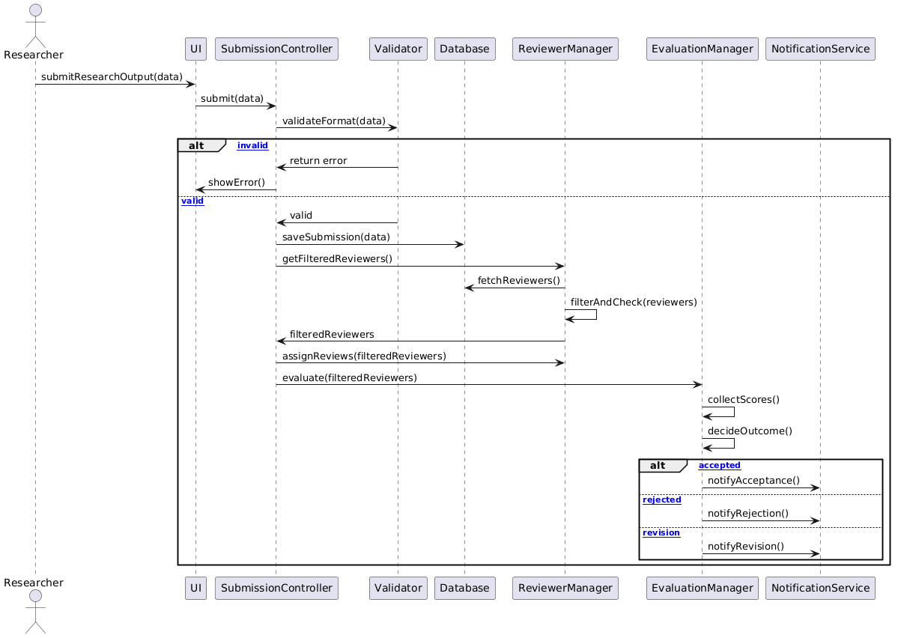

Key Improvements:
ReviewerManager handles all reviewer filtering in one step.
SubmissionController delegates evaluation and notification.
Decision logic is centralised in EvaluationManager.
NotificationService is only called by EvaluationManager.

Task 5: Optimised Implementation 

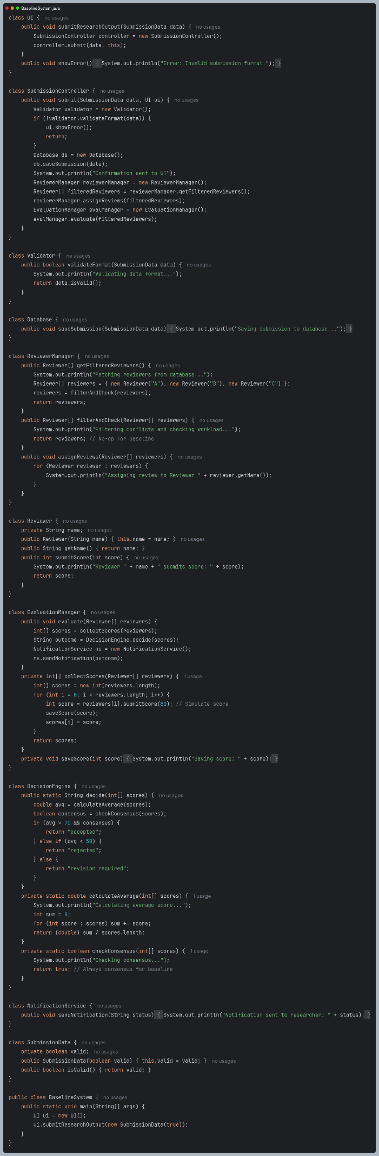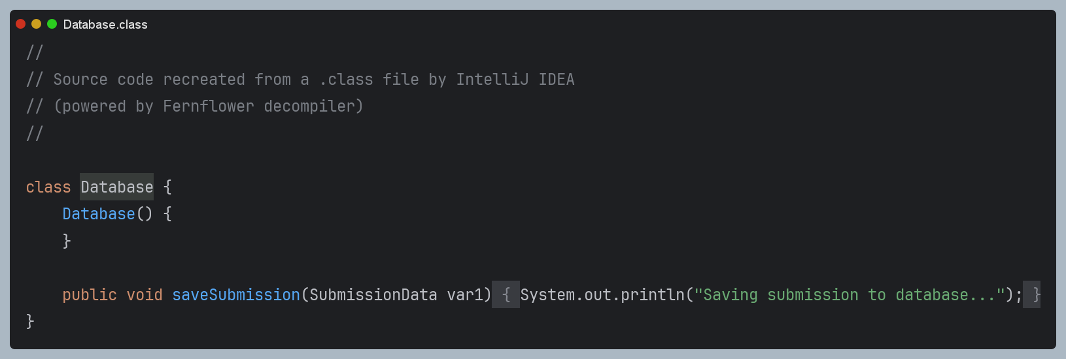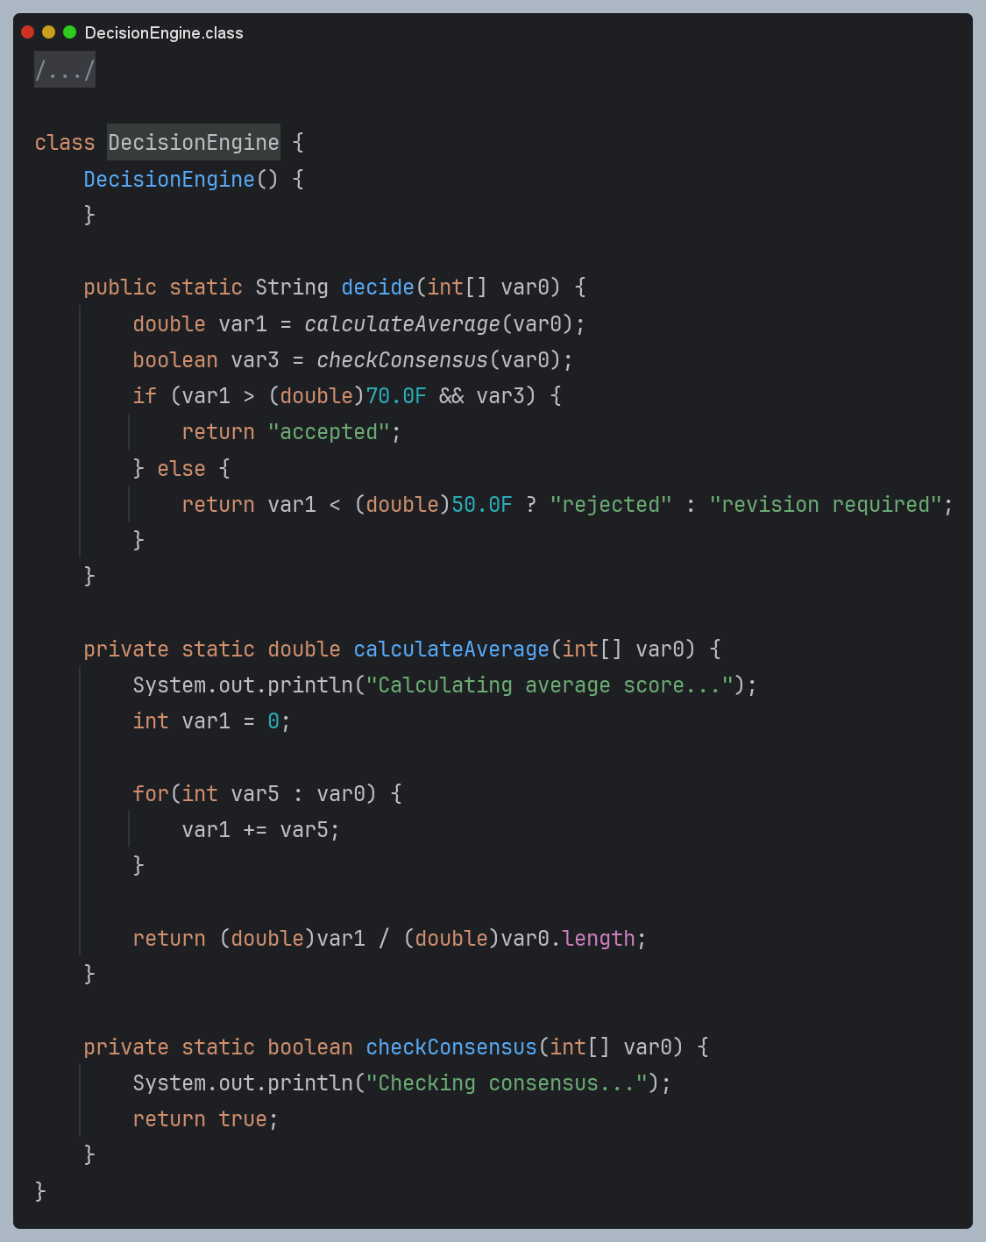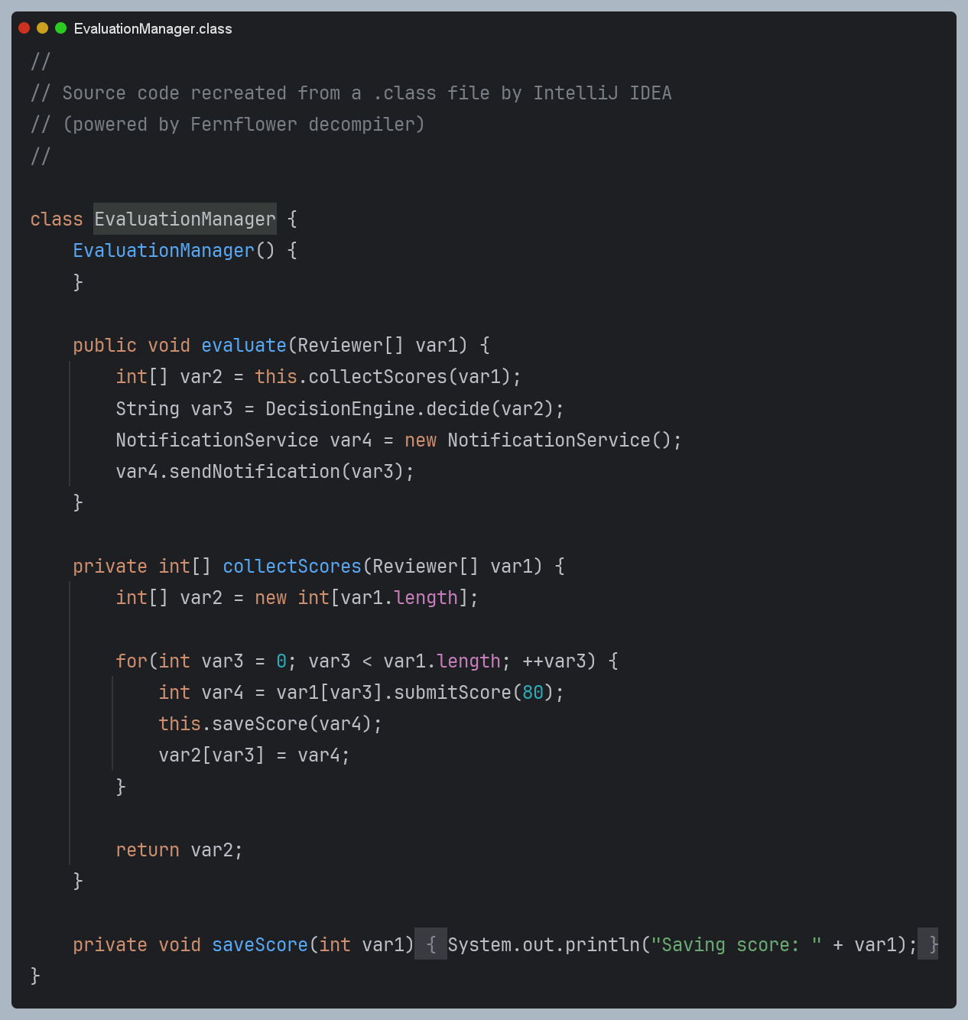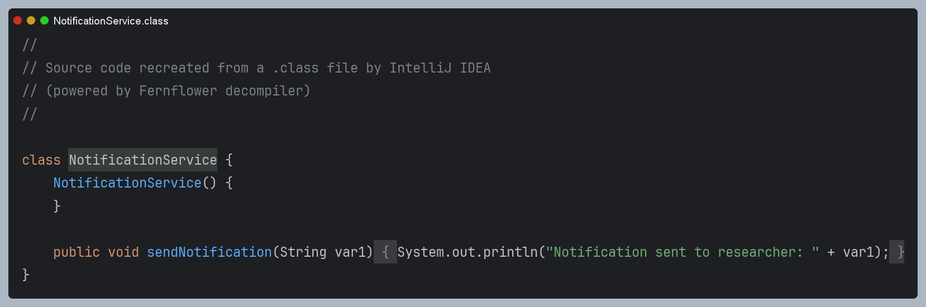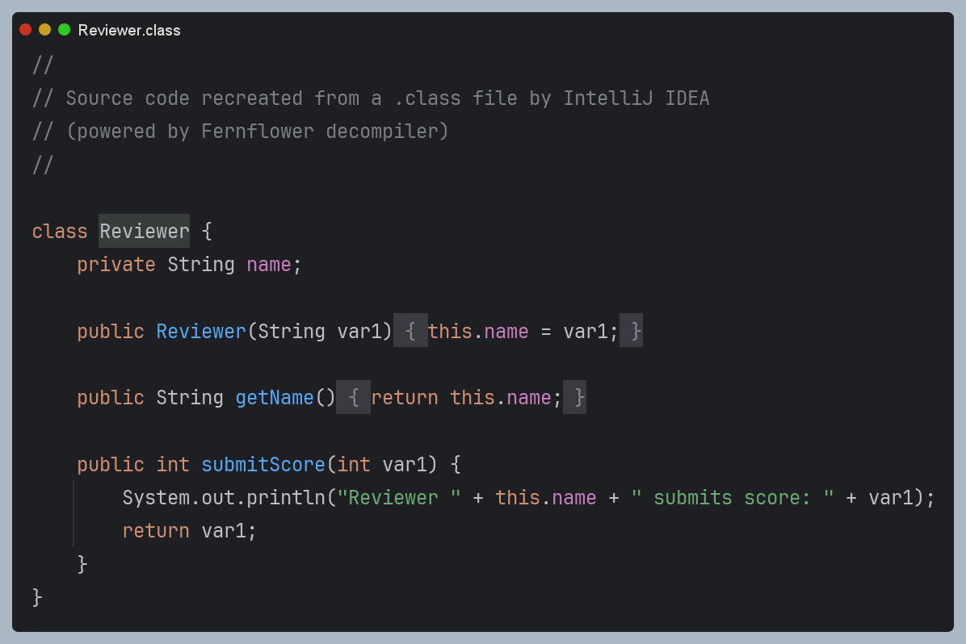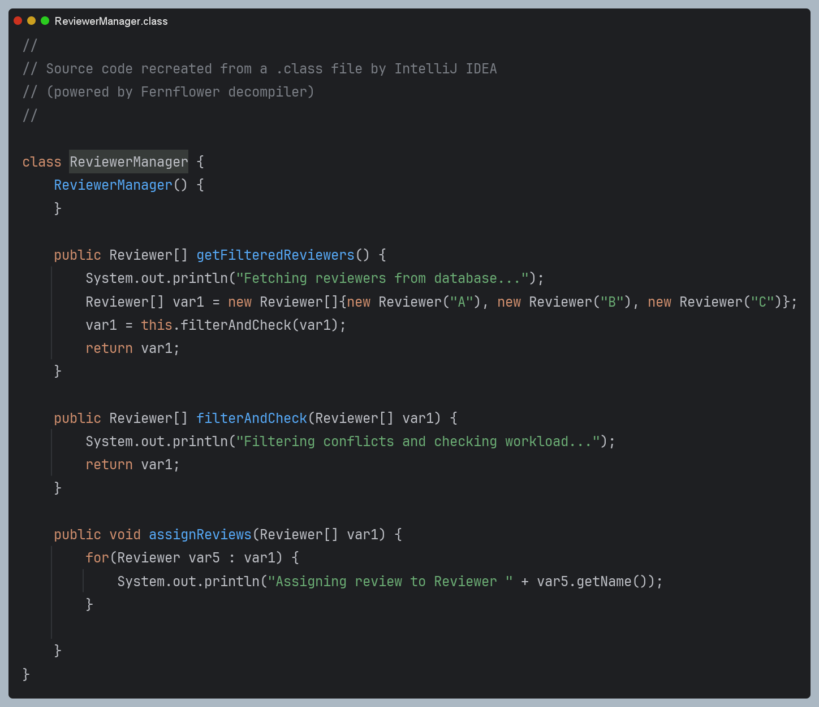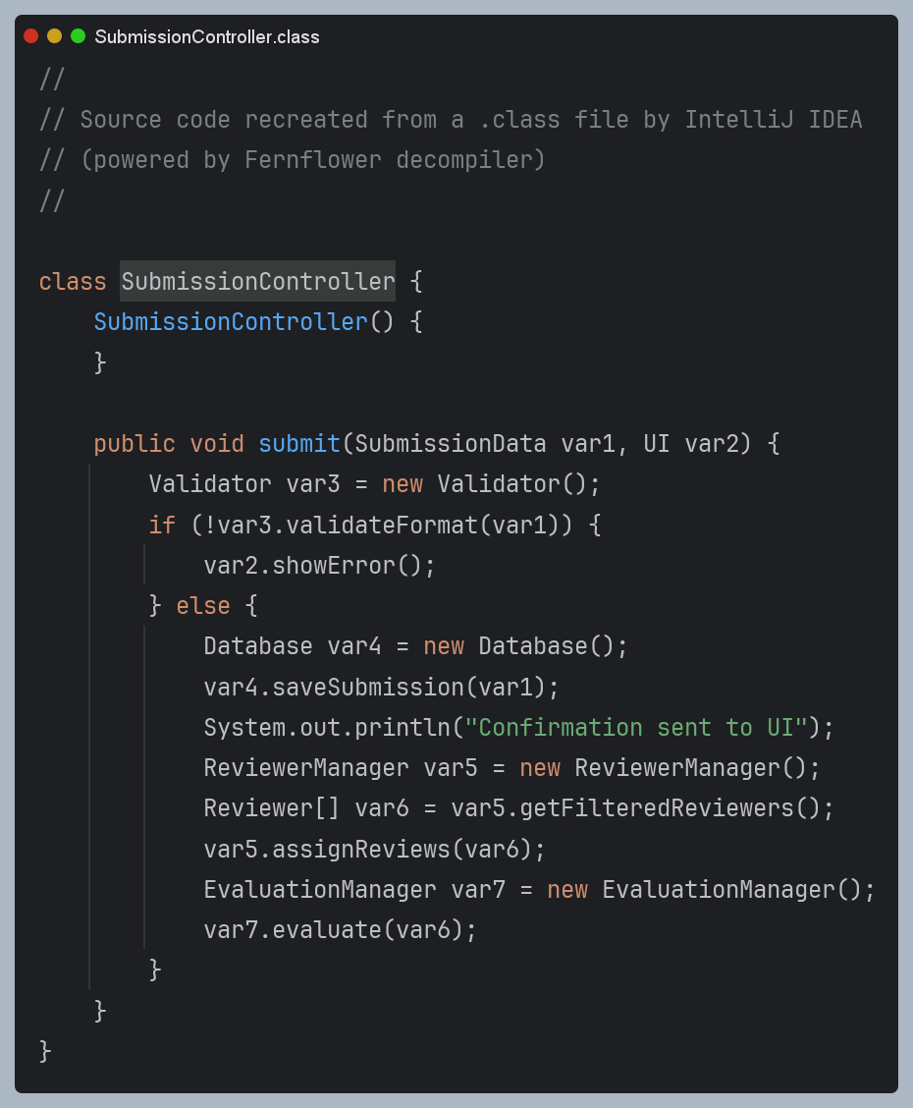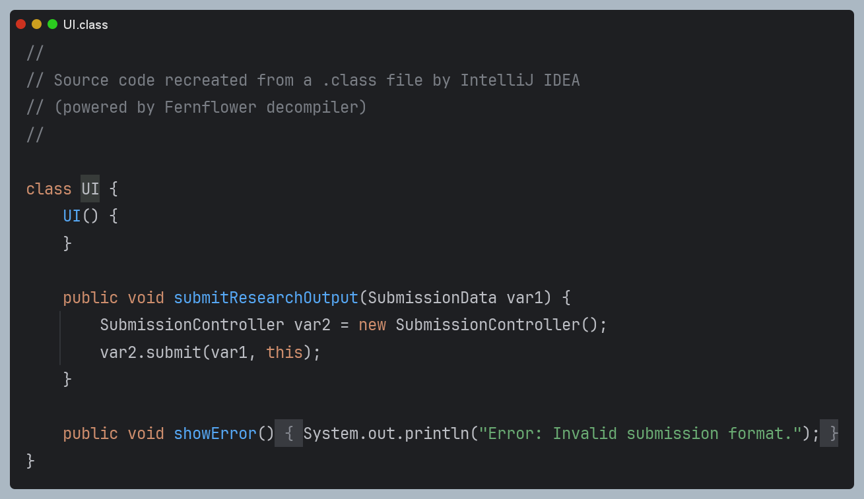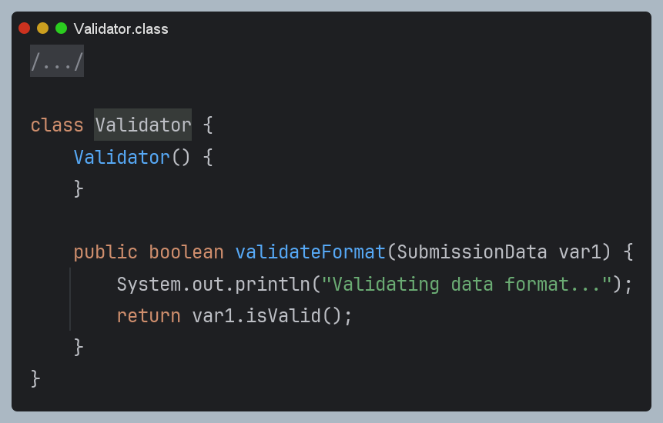

Task 6: Empirical Evaluation and Comparison
Metrics for Comparison
Number of Method Calls / Interactions
- Baseline System: Higher number of method calls due to redundant filtering, repeated object instantiations, and scattered decision logic.
- Optimized System: Reduced and more focused method calls through streamlined workflows and centralized logic.
Execution Time
- Baseline System: Slightly slower because of unnecessary processing and repeated operations.
- Optimized System: Slightly faster and more scalable due to improved control flow and reduced redundancy.
Code Complexity
- Baseline System: Higher complexity caused by large, less cohesive classes and duplicated responsibilities.
- Optimized System: Lower complexity with smaller, focused classes and centralized decision-making.
Maintainability Indicators
- Baseline System: More difficult to maintain due to tight coupling and scattered business rules.
- Optimized System: Easier to maintain and extend because of modular design and reduced coupling.
Metric | Baseline System | Optimized System
Method Calls | Higher (redundant interactions) | Lower (streamlined interactions)
Execution Time | Slightly higher | Slightly lower
Code Complexity | Higher | Lower
Maintainability | Lower | Higher
Responsibility Split | Poor separation of concerns | Clear separation of concerns
Coupling | High | Low
Cohesion | Low | High

Justification of Improvements
- Reduced redundant method calls and unnecessary object interactions.
- Centralized decision-making within the DecisionEngine.
- Improved separation of concerns through better class responsibility allocation.
- Increased maintainability and extensibility of the system.
- Reduced coupling and improved cohesion across components.

Trade-offs
- Requires slightly more upfront design and planning effort.
- Introduces additional classes/interfaces, but the benefits in maintainability, scalability, and readability outweigh the added structure.

